**Employee Benefit Application**

Benefits Dashboard Page

Add Employee dialog box

Update/Edit Employee dialog box

Delete Employee dialog box

**Calculation Formula**

Annual Salary -- (Salary before deductible * Number of paychecks) = 2000* 26 =52000$

Deductible for benefits -- (annual deduction for employee per year/ Number of paychecks) =38.46$ (just the employee)

1 dependent -- (Dependent Amount per year/number of paychecks per year)= 500/26 = 19.23$

Total Deductible per paycheck --Deductible Amount of the employee + Deductible amount for dependent =57.69$

Actual salary of the employee per paycheck after removing deduction--Salary before deductible -Deductible amount =2000-57.69 = 1942.31$

***Add Employee dialog box Scenarios***

**Defect 1:**

Description:

Misspelled field name: In Add Employee dialog box we see Instead of Dependents field name it's Dependants.

Seps:

1.Login to Employee benefit application.

2.Click on Add Employee button.

3.We see that field names for Dependents is misspelled as “Dependants”.

Attached is the screenshot

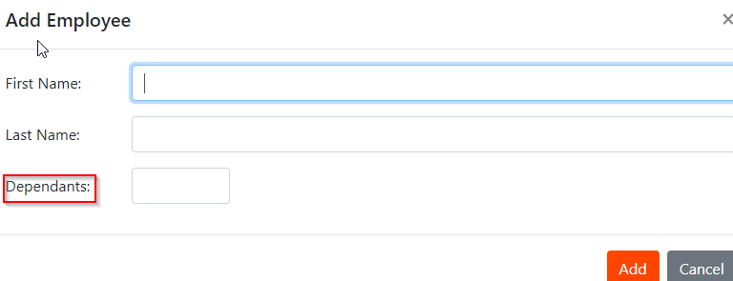

**Defect 2:**

Description:

The FirstName and LastName values entered in Add employee dialog box are swapped when shown in the dashboard

Steps

1.Click on Add Employee button on Dashboard

2.Enter values for FirstName (Danielle) and LastName(Ken)

3.Click Add

4.Page returns to Dashboard and we see Danielle is under LastName and Ken is under FirstName.

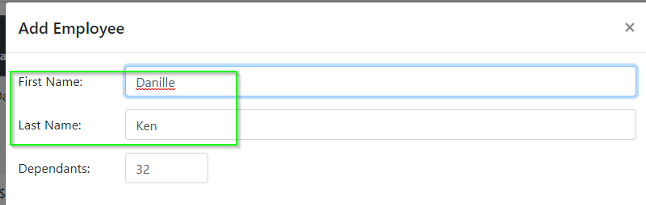

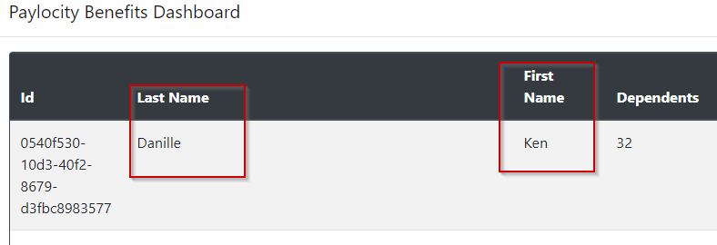

**Defect 3:**

Add employee dialog box is closing when we just click on the dashboard behind. More appropriate behavior would be clicking on Add,Cancel or X button at right top corner.

Steps:

1.Login to the Employee benefit application.

2.Click on Add Employee.

3.Click on the greyed-out area of the dashboard.

3.We see Add employee dialog box is closed, this might cause losing data which we have entered.

Miachel1234567891011121314151617181920212223242

FirtName field allows max of 50 chars, anything more than that entered and tried to Add will give 400 error.(highlighting the box displaying a message that 50 chars are allowed, and disabling Add button would have been user friendly)

**Defect 4:**

**Description**

Add button should not be enabled or notification/warning should be displayed if all required fields are not entered in Add Employee dialog box.

Just Entering FirstName or Last Name or Dependents and clicking on Add is giving a 400 error, but in UI there is no way of identifying what are the required fields.

Steps:

1.Login to the Employee benefit application.

2.Click on Add Employee.

3.Enter the value in either one of the fields First Name/LastName/Dependents.

4. We see Add button is still enabled and when we click on it we see 400 error in console but no warning is presented on application itself.

**Defect 5:**

Adding a lengthy name is pushing the columns out of the frame in the dashboard.

Steps:

1.Login to the Employee benefit application.

2.Click on Add Employee.

3.Enter the value a lengthy First Name or lengthy LastName and dependents.

4.Click Add

5.We see the columns at the right side of the dashboard are pushed out of frame

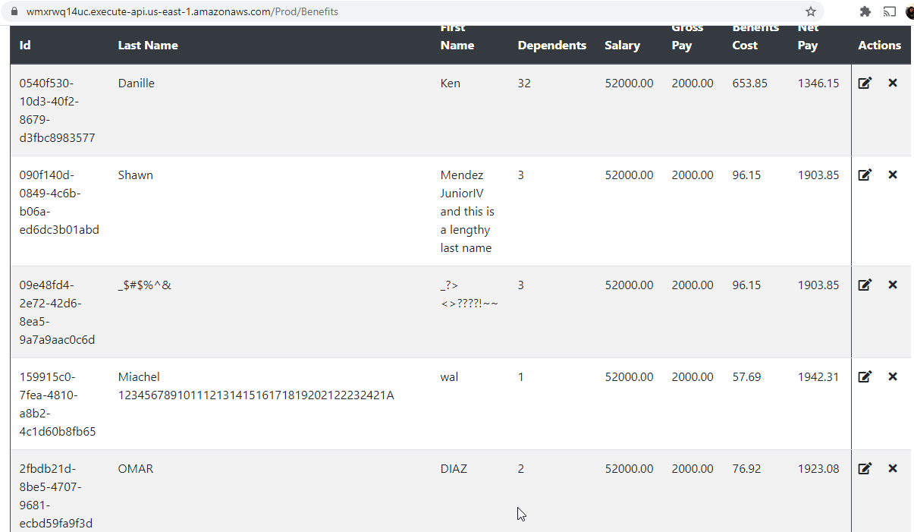

Defect 6:

We can add an employee with only Numbers or special chars and no validation is shown.

Steps:

1.Login to the Employee benefit application.

2.Click on Add Employee.

3.Enter the either a numeric value or a only special char value First Name or lengthy LastName

4.Enter dependents

5.Click Add

6. We see the employee with numeric values for name and special char value for names are saved.

7. We don’t see any validation on what kind of values are valid.

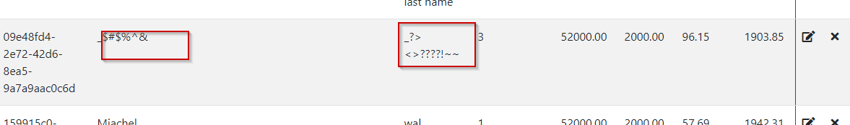

Update Employee validation

Defect 7:

Wrong header of Update Employee dialog box. Header of the dialog box is shown as Add employee when we are tying to do Update employee.

Steps:

1.Login to the Employee benefit application.

2.Click on pen symbol next to each record under Actions column.

3.Update dialog box opens up, but we see “Add Employee” as the header.

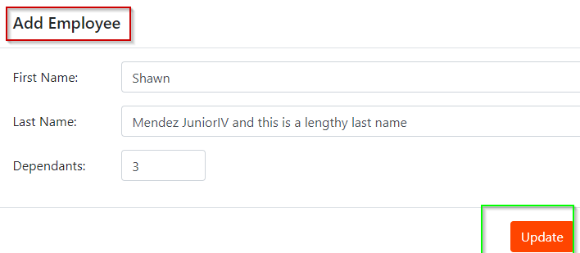

**Defect 8:**

Update Employee call is also adding new employee.

Steps:

1.Login to Postman app.

2. Click on PUT Update Employee request.

3.Pass new ID,firstname,lastName and Dependents and send the request.

4. We see a new employee got added but with zero salary.

**Defect 9:**

Delete Employee with a non existing id is returning success

Delete employee with id which is already deleted is still showing success

Steps:

1.Login to Postman app.

2. Click on DEL Delete Employee request.

3.Pass new ID of already deleted employee or any new ID which is not assigned to an existing employee.

4. We see 200 OK status, but don’t see any validation or check being done to see if employee exists before doing DELETE function.

**Observations**

Dependents does not accept alphabets/Special char and throws 500 error, but in UI it does not give any indication to the user correct value to enter.

Entering more than 32 dependents is giving 400 error

In the main dashboard when we add an employee it’s not inserted or shown in any order, it’s not sorted alphabetically or most recently added is shown at the top of the page, which makes it difficult to search for the employee.

After 30 mins on the dashboard with no action was not able to add/update/delete any employee..401 error